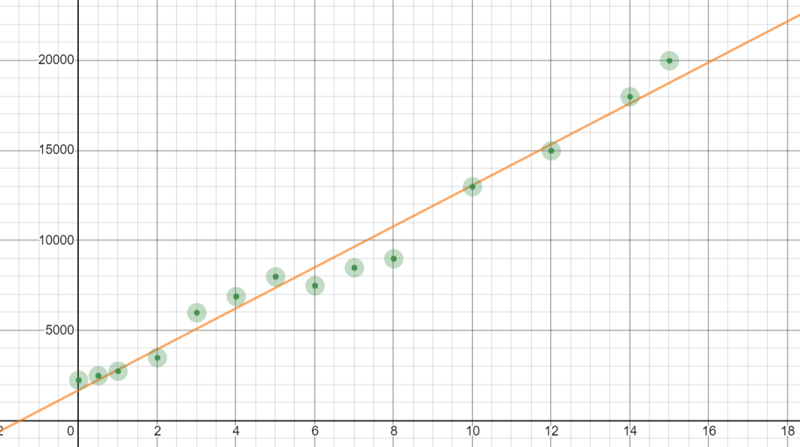

x | y | xy | $$x^{2}$$ | y - $\overline{y}$ | $${(y - \overline{y})}^{2}$$
0,5 | 2500 | 1250 | 0,25 | -6278,57 | 39420441,24
0,0 | 2250 | 0 | 0 | -6528,57 | 42622226,24
1,0 | 2750 | 2750 | 1 | -6028,57 | 36343656,24
5,0 | 8000 | 40000 | 25 | -778,57 | 606171,24
8,0 | 9000 | 72000 | 64 | 221,43 | 49031,24
4,0 | 6900 | 27600 | 16 | -1878,57 | 3529025,24
15,0 | 20000 | 300000 | 225 | 11221,43 | 125920491,24
7,0 | 8500 | 59500 | 49 | -278,57 | 77601,24
3,0 | 6000 | 18000 | 9 | -2778,57 | 7720451,24
2,0 | 3500 | 7000 | 4 | -5278,57 | 27863301,24
12,0 | 15000 | 180000 | 144 | 6221,43 | 38706191,24
10,0 | 13000 | 130000 | 100 | 4221,43 | 17820471,24
14,0 | 18000 | 252000 | 196 | 9221,43 | 85034771,24
6,0 | 7500 | 45000 | 36 | -1278,57 | 1634741,24
87,5 | 122900 | 1135100 | 869,25 |  | 427348571,36

Rata-rata y = 8778,57
ŷ =
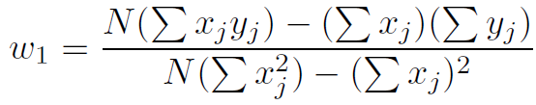
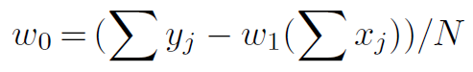
W1 = $\frac{14 \left(1135100\right) - (87,5)(122900) }{14\left(869,25\right) - (7656,25)}$ = $\frac{15891400 - 10753750}{12169,5 - 7656,25}$ = $\frac{5137650}{4513,25}$ = 1138,35
W0 = $\frac{(122900 - 1138,35(87,5) }{14}$ = $\frac{122900 - 99605,625 }{14}$ = $\frac{23294,375}{14}$ = 1663,88
ŷ | ŷ - $\overline{y}$ | $${(ŷ - \overline{y})}^{2}$$
2233,055 | -6545,515 | 42843766,62
1663,88 | -7114,69 | 50618813,8
2802,23 | -5976,34 | 35716639,8
7355,63 | -1422,94 | 2024758,24
10770,68 | 1992,11 | 3968502,25
6217,28 | -2561,29 | 6560206,46
18739,13 | 9960,56 | 99212755,51
9632,33 | 853,76 | 728906,14
5078,93 | -3699,64 | 13687336,13
3940,58 | -4837,99 | 23406147,24
15324,08 | 6.545,51 | 42843701,16
13047,38 | 4268,81 | 18222738,82
17600,78 | 8822,21 | 77831389,28
8493,98 | -284,59 | 80991,47
 |  | 417746.652,92

Gradient descent
Berguna untuk mencari W1 dan W0 yang baru, serta mencari MSE
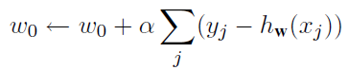
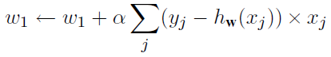
y | ŷ | y-hw(x) | $${(y-hw(x))}^{2}$$
2500 | 2233,055 | 266,93 | 71251,62
2250 | 1663,88 | 586,1 | 343513,21
2750 | 2802,23 | -52,24 | 2729,02
8000 | 7355,63 | 644,36 | 415199,81
9000 | 10770,68 | -1770,68 | 3135307,66
6900 | 6217,28 | 682,71 | 466092,94
20000 | 18739,13 | 1260,88 | 1589818,37
8500 | 9632,33 | -1132,33 | 1282171,23
6000 | 5078,93 | 921,06 | 848351,52
3500 | 3940,58 | -440,59 | 194119,55
15000 | 15324,08 | -324,07 | 105021,36
13000 | 13047,38 | -47,38 | 2244,86
18000 | 17600,78 | 399,23 | 159384,59
7500 | 8493,98 | -993,98 | 987996,24
122900 |  | 0 | 9603201,98

Karena nilai dari $\sum{(y-hw(x)) }$= 0, maka nilai W0 dan W1 tetap.
W0 = 1663,88
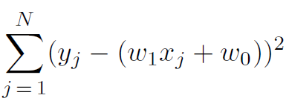
W1 = 1138,35
MSE = = 9603201,98

$R^{2}$ = $\frac{\sum{{(ŷ - \overline{y})}^{2}}}{\sum{{(y - \overline{y})}^{2}}}$ = $\frac{417746.652,92}{427348571,36}$ = 0,9775 = 97,75%

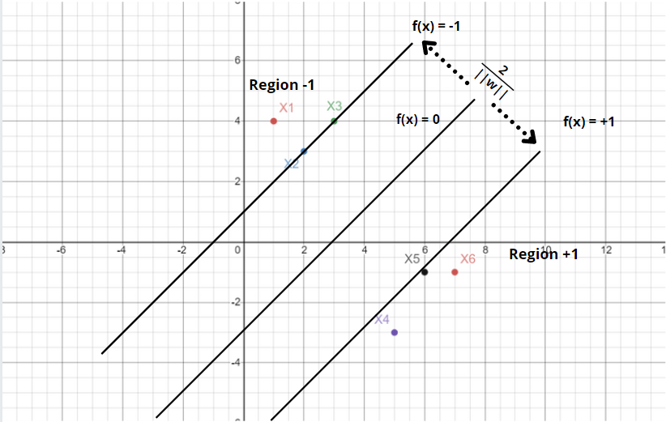

Hard margin
Goals : To draw a hyper plane to linearly separate data.
Calculating margin :
y = 1 = w^{T}. X + b >= 1
y = -1 = w^{T}. X + b <= 1
Combined
y(w^{T}. x + b) >= 1
Formula:
Minimizew,b $\frac{1}{2}$ ${|\left|w\right||}^{2}$
or
y(w^{T}. x + b) >= 1 $∀$(x,y)
constraint must hold for all training datapoints (x,y).

x1 (1, 4)
4(w^{T} + b) >= 1
4 w^{T} + b >= 1
x4 (5, -3)
5(-3w^{T} + b) >= 1
-15 w^{T}+ 5b >=1

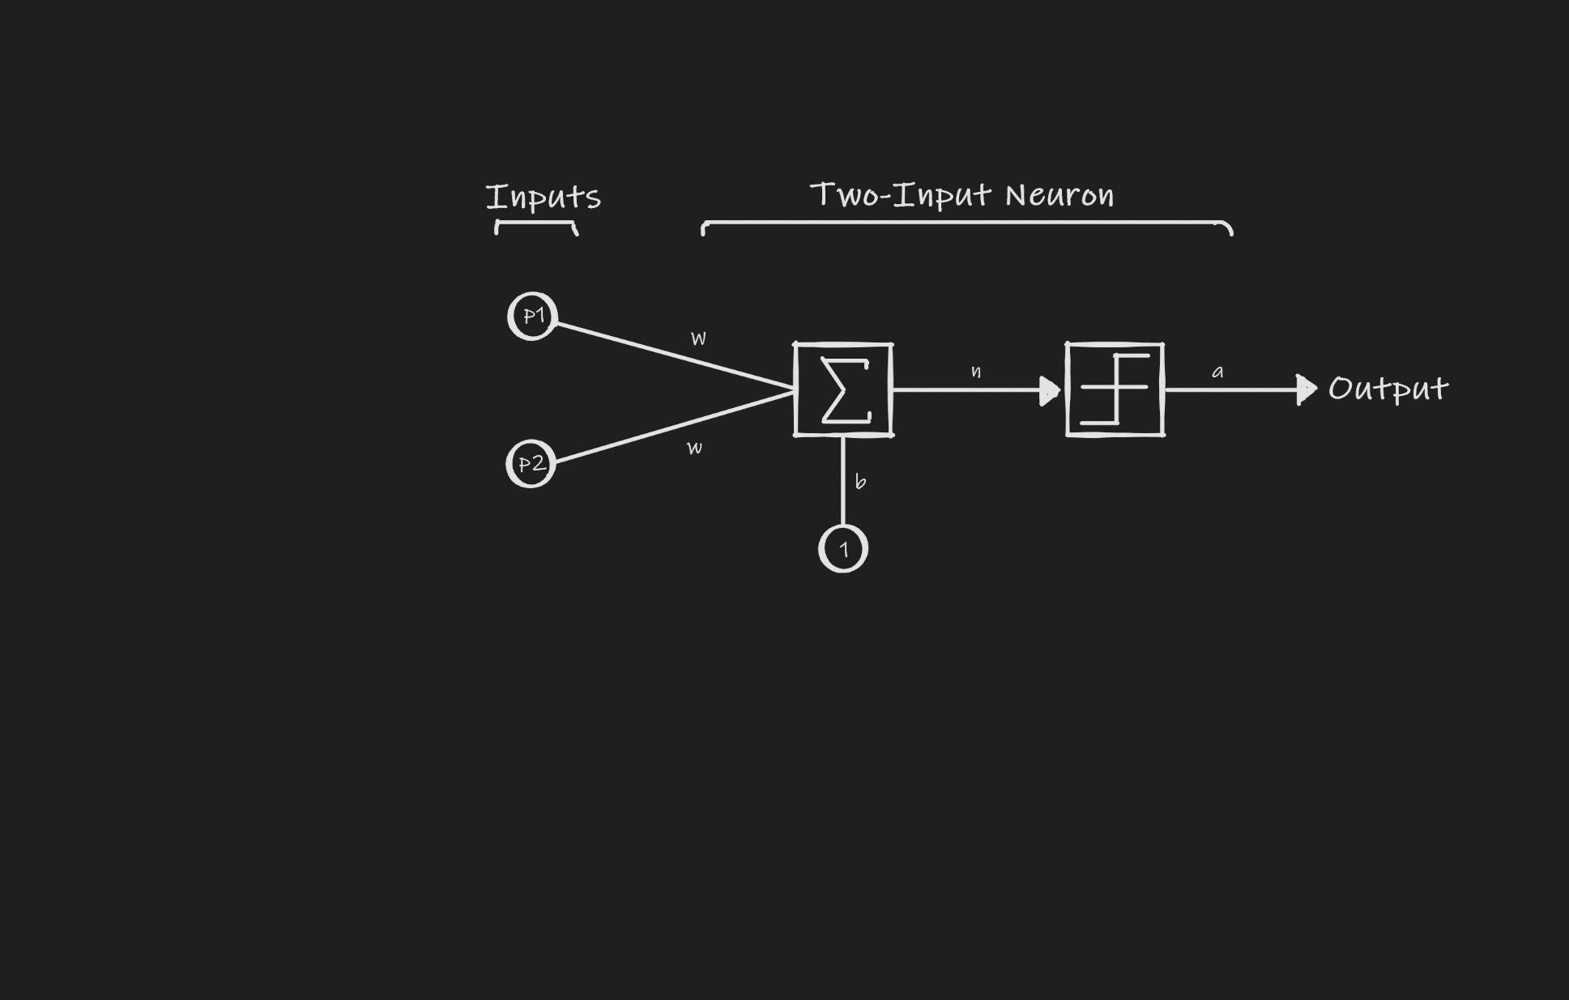
p = $\left[\begin{aligned}shape \\ texture \\ weight\end{aligned}\right]$
Jika buah bulat, maka -1, dan jika berbentuk panjang, maka 1.
Jika tekstur buah halus, maka -1, dan jika tekstur buah kasar, maka 1.
Jika berat buah > 500g, maka -1, dan jika berat buah < 500g, maka 1.

banana = p1 = $\left[\begin{aligned}\text{-1} \\ \text{1} \\ \text{-1}\end{aligned}\right]$
apple = p2 = $\left[\begin{aligned}\text{1} \\ \text{1} \\ \text{-1}\end{aligned}\right]$

$a=hardlims\left(\left[W\text{1},\text{1} W\text{1},\text{2} W\text{1},\text{3}\right] \left[\begin{aligned}p\text{1} \\ p\text{2} \\ p\text{3}\end{aligned}\right]+b\right)$

Banana:
$a=hardlims\left(\text{n}\right)$, jika n>=0 maka a = 1, jika n<0 maka a = -1
$a=hardlims\left(\left[\text{0.5 -1 -0.5}\right] \left[\begin{aligned}\text{-1} \\ \text{ 1} \\ \text{-1}\end{aligned}\right]+0.5\right)$
$a=hardlims\left(\text{-0.5}\right)$ = -1

Apple:
$a=hardlims\left(\text{n}\right)$, jika n>=0 maka a = 1, jika n<0 maka a = -1
$a=hardlims\left(\left[\text{0.5 -1 -0.5}\right] \left[\begin{aligned}\text{1} \\ \text{ 1} \\ \text{-1}\end{aligned}\right]+0.5\right)$
$a=hardlims\left(0.5\right)$ = 1

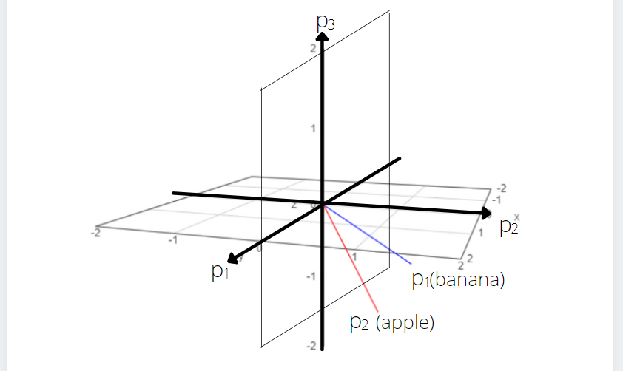
Berdasarkan prototype vectors di atas, dapat dilihat p2, p3 plane menjadi decision boundary, maka didapatkan
p1 = 0
atau
$\left[W\text{1},\text{1} W\text{1},\text{2} W\text{1},\text{3}\right] \left[\begin{aligned}p\text{1} \\ p\text{2} \\ p\text{3}\end{aligned}\right]+b$ = 0

Karena decision boundary-nya melewati origin/asal (0,0), maka biasnya 0
Banana:
$\left[W\text{1},\text{1} W\text{1},\text{2} W\text{1},\text{3}\right] \left[\begin{aligned}0 \\ 1 \\ \text{-1}\end{aligned}\right]+0$ = 0

Apple:
$\left[W\text{1},\text{1} W\text{1},\text{2} W\text{1},\text{3}\right] \left[\begin{aligned}0 \\ 1 \\ \text{-1}\end{aligned}\right]+0$ = 0
Agar didapatkan hasil (a) = 0, maka $W\text{1},\text{2}$dan $W\text{1},\text{3}$ harus 0, sedangkan $W\text{1},\text{1}$ tetap 0.5.
Maka dapat disimpulkan, optimal weight W = $\left[0.5 0 0\right]$ dan bias b = 0.
Dengan begitu, hal di atas dapat digunakan untuk membedakan buah dan dapat mengarahkan buah ke tempat penyimpanan yang sesuai.

- Attribute: Marital Status
Values (Marital Status) = Married, Single, Divorced
S = $\left[\text{3+, 7-}\right]$ Entropy(S) = $- \frac{3}{10}\log_{2}{\frac{3}{10}- \frac{7}{10}\log_{2}{\frac{7}{10}}}$ = 0,881290899
SMarried = $\left[\text{0+, -4}\right]$ Entropy(SMarried) = 0
SSingle = $\left[\text{2+, 2-}\right]$ Entropy(SSingle) = $- \frac{2}{4}\log_{2}{\frac{2}{4}- \frac{2}{4}\log_{2}{\frac{2}{4}}}$ = 1
SDivorced = $\left[\text{1+, 1-}\right]$ Entropy(SDivorced) = $- \frac{1}{2}\log_{2}{\frac{1}{2}- \frac{1}{2}\log_{2}{\frac{1}{2}}}$ = 1

Gain (S, Marital Status) = Entropy(S) $- \sum_{v ∈(Married, Single,Divorced)}{\frac{\left|S\text{v}\right|}{\left|S\right|} Entropy(S\text{v})}$
Gain (S, Marital Status) = Entropy(S) $-$ $\frac{4}{10} Entropy(S\text{Married}\text{)}- \frac{4}{10} Entropy(S\text{Single})-$ $\frac{2}{10} Entropy(S\text{Divorced})$
Gain (S, Marital Status) = 0,881290899 $-$ 0 $- \frac{4}{10}$ * 1 $- \frac{2}{10}*$1
Gain (S, Marital Status) = 0,281290899

Attribute: Refund
Values (Refund) = Yes, No
S = $\left[\text{3+, 7-}\right]$ Entropy(S) = $- \frac{3}{10}\log_{2}{\frac{3}{10}- \frac{7}{10}\log_{2}{\frac{7}{10}}}$ = 0,881290899
SYes = $\left[\text{0+, 3-}\right]$ Entropy(SYes) = 0
SNo = $\left[\text{3+, 4-}\right]$ Entropy(SNo) = $- \frac{3}{7}\log_{2}{\frac{3}{7}- \frac{4}{7}\log_{2}{\frac{4}{7}}}$ = 0,985228136

Gain (S, Refund) = Entropy(S) $- \sum_{v ∈(Yes,No)}{\frac{\left|S\text{v}\right|}{\left|S\right|} Entropy(S\text{v})}$
Gain (S, Refund) = Entropy(S) $-$ $\frac{3}{10} Entropy(S\text{Yes}\text{)}- \frac{7}{10} Entropy(S\text{No})$
Gain (S, Refund) = 0,881290899 $-$ $0$ $- \frac{7}{10}*$0,985228136
Gain (S, Refund) = 0,1916312038

Attribute: Taxable Income
Values (Taxable Income) = Greater Than or Equal to 100K, Less Than 100K
S = $\left[\text{3+, 7-}\right]$ Entropy(S) = $- \frac{3}{10}\log_{2}{\frac{3}{10}- \frac{7}{10}\log_{2}{\frac{7}{10}}}$ = 0,881290899
SGreater Than or Equal to 100K = $\left[\text{0+, 4-}\right]$ Entropy(SGreater Than or Equal to 100K) = 0
SLess Than 100K = $\left[\text{3+, 3-}\right]$ Entropy(SLess Than 100K) = $- \frac{3}{6}\log_{2}{\frac{3}{6}- \frac{3}{6}\log_{2}{\frac{3}{6}}}$ = 1

Gain (S, Taxable Income) = Entropy(S) $- \sum_{v ∈(Greater Than or Equal to 100K ,Less Than 100K)}{\frac{\left|S\text{v}\right|}{\left|S\right|} Entropy(S\text{v})}$
Gain (S, Taxable Income) = Entropy(S) $-$ $\frac{4}{10} Entropy(SGreater Than or Equal to 100K\text{)}- \frac{6}{10} Entropy(SLess Than 100K)$
Gain (S, Taxable Income) = 0,881290899 $-$ $0$ $- \frac{6}{10}*$1
Gain (S, Taxable Income) = 0,281290899
Maka,
Gain (S, Marital Status) = 0,281290899 Maximum Gain
Gain (S, Refund) = 0,1916312038
Gain (S, Taxable Income) = 0,281290899

ID | Refund | Taxable Income | Cheat
5 | No | 95K | Yes
7 | Yes | 220K | No

Attribute: Refund
Values (Refund) = Yes, No
SMarital Status = $\left[\text{1+, 1-}\right]$ Entropy(SMarital Status) = $- \frac{1}{2}\log_{2}{\frac{1}{2}- \frac{1}{2}\log_{2}{\frac{1}{2}}}$ = 1
SYes = $\left[\text{0+, 1-}\right]$ Entropy(SYes) = 0
SNo = $\left[\text{1+, 0-}\right]$ Entropy(SNo) = $0$

Gain (S, Refund) = Entropy(S) $- \sum_{v ∈(Yes,No)}{\frac{\left|S\text{v}\right|}{\left|S\right|} Entropy(S\text{v})}$
Gain (S, Refund) = Entropy(S) $-$ $\frac{1}{2} Entropy(S\text{Yes}\text{)}- \frac{1}{2} Entropy(S\text{No})$
Gain (S, Refund) = 1 $-$ $0$ $- 0$
Gain (S, Refund) = 1
ID | Refund | Taxable Income | Cheat
1 | Yes | 125K | No
3 | No | 70K | No
8 | No | 85K | Yes
10 | No | 90K | Yes

Attribute: Taxable Income
Values (Taxable Income) = Greater Than or Equal to 100K, Less Than 100K
SMarital Status = $\left[\text{2+, 2-}\right]$ Entropy(SMarital Status) = $- \frac{2}{4}\log_{2}{\frac{2}{4}- \frac{2}{4}\log_{2}{\frac{2}{4}}}$ = 1
SGreater Than or Equal to 100K = $\left[\text{0+, 1-}\right]$ Entropy(SGreater Than or Equal to 100K) = 0
SLess Than 100K = $\left[\text{2+, 1-}\right]$ Entropy(SLess Than 100K) = $- \frac{2}{3}\log_{2}{\frac{2}{3}- \frac{1}{3}\log_{2}{\frac{1}{3}}}$ = 0,9182958341

Gain (S, Taxable Income) = Entropy(S) $- \sum_{v ∈(Greater Than or Equal to 100K ,Less Than 100K)}{\frac{\left|S\text{v}\right|}{\left|S\right|} Entropy(S\text{v})}$
Gain (S, Taxable Income) = Entropy(S) $-$ $\frac{1}{4} Entropy(SGreater Than or Equal to 100K\text{)}- \frac{3}{4} Entropy(SLess Than 100K)$
Gain (S, Taxable Income) = 1 $-$ $0$ $- \frac{3}{4}*$0,9182958341
Gain (S, Taxable Income) = 0,3112781244
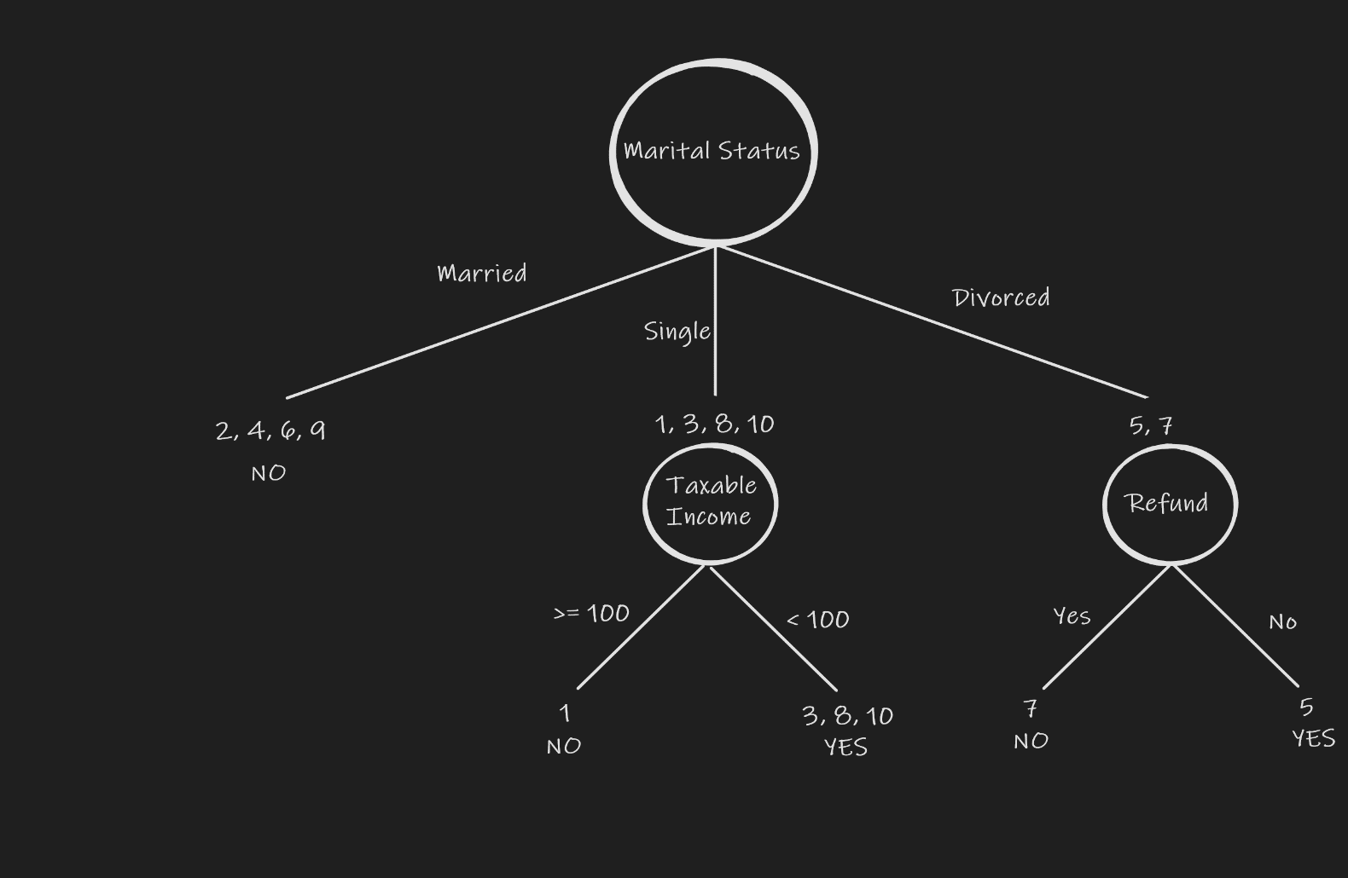

Pada bagian (3, 8, 10), karena target label 3 adalah No dan target label (8, 10) adalah Yes, maka terdapat dua probability, yaitu Yes = 0,67 dan No = 0,33.
X1 (No, Single, 95K) = Yes
X2 (Yes, Divorced, 120K) = No

- A.
D1 = Shipment of gold damaged in a fire
D2 = Delivery of silver arrived in a silver truck
D3 = Shipment of gold arrived in a truck

Idf values:
Arrive = $\log{(\frac{3}{2})}$ = 0,1761
Damage = $\log{(\frac{3}{1})}$= 0,4771
Delivery = $\log{(\frac{3}{1})}$= 0,4771
Fire = $\log{(\frac{3}{1}) }$= 0,4771
Gold = $\log{(\frac{3}{2})}$ = 0,1761
Shipment = $\log{(\frac{3}{2})}$ = 0,1761
Silver = $\log{(\frac{3}{1})}$ = 0,4771
Truck = $\log{(\frac{3}{2})}$ = 0,1761

Tf scores for all document:
 | Arrive | Damage | Delivery | Fire | Gold | Shipment | Silver | Truck
D1 | 0 | 1 | 0 | 1 | 1 | 1 | 0 | 0
D2 | 1 | 0 | 1 | 0 | 0 | 0 | 2 | 1
D3 | 1 | 0 | 0 | 0 | 1 | 1 | 0 | 1

Multiply tf scores by the idf values:
 | Arrive | Damage | Delivery | Fire | Gold | Shipment | Silver | Truck
D1 | 0 | 0,4771 | 0 | 0,4771 | 0,1761 | 0,1761 | 0 | 0
D2 | 0,1761 | 0 | 0,4771 | 0 | 0 | 0 | 0,9542 | 0,1761
D3 | 0,1761 | 0 | 0 | 0 | 0,1761 | 0,1761 | 0 | 0,1761

Weight = Tf scores * (Idf values + 1)
 | Arrive | Damage | Delivery | Fire | Gold | Shipment | Silver | Truck
D1 | 0 | 1,4771 | 0 | 1,4771 | 1,1761 | 1,1761 | 0 | 0
D2 | 1,1761 | 0 | 1,4771 | 0 | 0 | 0 | 1,9542 | 1,1761
D3 | 1,1761 | 0 | 0 | 0 | 1,1761 | 1,1761 | 0 | 1,1761

B.
Given query:
- gold silver truck
- gold truck
We divide the frequency by the maximum frequency = 2 and multiply it with the idf values
 | Arrive | Damage | Delivery | Fire | Gold | Shipment | Silver | Truck
q(1) | 0 | 0 | 0 | 0 | ($\frac{1}{2}$)* 0,1761  = 0,08805 | 0 | ($\frac{1}{2}$)* 0,4771  = 0,23855 | ($\frac{1}{2}$) * 0,1761  = 0,08805
q(2) | 0 | 0 | 0 | 0 | ($\frac{1}{2}$)* 0,1761  = 0,08805 | 0 | 0 | ($\frac{1}{2}$) * 0,1761  = 0,08805

Length of D1 = $\sqrt{({0,1761}^{2}+{0,1761}^{2}+{0,4771}^{2}+{0,4771}^{2})}$ = 0,7192
Length of D2 = $\sqrt{({0,4771}^{2}+{0,4771}^{2}+{0,1761}^{2}+{0,4771}^{2}+{0,1761}^{2}) }$= 0,8631
Length of D3 = $\sqrt{({0,1761}^{2}+{0,1761}^{2}+{0,1761}^{2}+{0,1761}^{2})}=$0,3522
Length of q(1) = $\sqrt{({0,1761}^{2}+{0,4771}^{2}+{0,1761}^{2})}$ = 0,5382
Length of q(2) = $\sqrt{({0,1761}^{2}+{0,1761}^{2})}$ = 0,2491

The similarity scores (query 1) are:
cosSim(D1,q1) = $\frac{\left(0*0+0,4771*0+0*0+0,4771*0+0,1761*0,08805+0,1761*0+0*0,23855+0* 0,08805\right)}{\left(0,7192*0,5382\right)}$
cosSim(D1,q1) = 0,040058561

cosSim(D2,q1) = $\frac{\left(0,1761*0+0*0+0,4771*0+0*0+0,*0,08805+0*0+0,9542*0,23855+0,1761* 0,08805\right)}{\left(0,8631*0,5382\right)}$
cosSim(D2,q1) = 0,523400058

cosSim(D3,q1) = $\frac{\left(0,1761*0+0*0+0*0+0*0+0,1761*0,08805+0,1761*0+0*0,23855+0,1761* 0,08805\right)}{\left(0,3522*0,5382\right)}$
cosSim(D3,q1) = 0,163600892

According to the similarity scores, the final order in which the documents are
presented as result to the query(1) will be: D2, D3, D1.

The similarity scores (query 2) are:
cosSim(D1,q2) = $\frac{\left(0*0+0,4771*0+0*0+0,4771*0+0,1761*0,08805+0,1761*0+0*0+0* 0,08805\right)}{\left(0,7192*0,2491\right)}$
cosSim(D1,q2) = 0,086549649

cosSim(D2,q2) = $\frac{\left(0,1761*0+0*0+0,4771*0+0*0+0,*0,08805+0*0+0,9542*0+0,1761* 0,08805\right)}{\left(0,8631*0,2491\right)}$
cosSim(D2,q2) = 0,072119693

cosSim(D3,q2) = $\frac{\left(0,1761*0+0*0+0*0+0*0+0,1761*0,08805+0,1761*0+0*0+0,1761* 0,08805\right)}{\left(0,3522*0,2491\right)}$
cosSim(D3,q2) = 0,353472501

According to the similarity scores, the final order in which the documents are
presented as result to the query (2) will be: D3, D1, D2.

Terima kasih Pak, atas ajarannya selama satu semesternya.

